Supporting the quality of publicly funded training in South Australia

The Quality and Compliance Monitoring Framework

South Australia’s WorkReady initiative brings together government investment for training, employment and skills initiatives and aims to support students, job seekers, employers, industry and the training sector to respond to changing social, geographic and economic circumstances.
To ensure the community has confidence in the services provided through public investment, the Skills and Employment division of the Department of State Development has established a Quality and Compliance Monitoring Framework to guide its quality assurance activities. These activities include monitoring the quality of services delivered by registered training organisations (RTO) and other bodies contracted under the WorkReady initiative, as well as monitoring the compliance of registered employers of trainees and apprentices with the Training and Skills Development Act 2008.

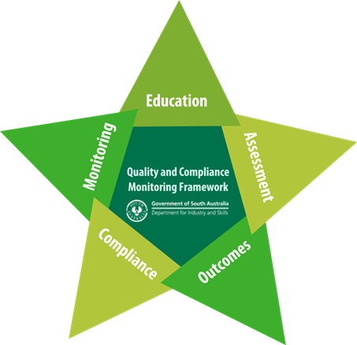

Monitoring & Compliance

The Quality and Compliance Monitoring Framework outlines the set of principles that will underpin the activities of the department.

These principles cover the broad areas of Education, Assessment, Monitoring and Compliance, and Outcomes. Education
Information explaining the intent and requirements of programs and regulation will be made available to stakeholders in a range of ways that are easy to understand.
Assessment

Prospective applicants will be required to satisfy assessment criteria, which will be made publicly available. Decisions will be made fairly and equitably and will be clearly communicated to applicants.

A risk-based approach to monitoring and compliance will be applied and RTOs/other service providers/employers will be given reasonable opportunity to address any non-compliance. If subsequent action is taken by the department, it will be proportionate to the nature and level of the non-compliance.

Outcomes

The department will seek to improve its assessment, and monitoring and compliance activities through regular reviews and will consider feedback provided by stakeholders. The department will also offer support to providers/employers to assist them to build their capability.

Monitoring registered training organisations (RTOs)

The department’s approach to monitoring RTOs seeks to complement, not duplicate, the role of the Australian Skills Quality Authority (ASQA) – the national VET regulator – which has responsibility for ensuring RTOs are compliant with the national Standards for Registered Training Organisations (RTOs) 2015.

The department will use qualitative and quantitative measures to routinely monitor RTOs against a range of indicators. When necessary, RTOs will be requested to provide further information to assist with inquiries.

Expectations

Through the implementation of the Quality and Compliance Monitoring Framework, the following behaviors can be expected:

Organisation/ individual | …will:
Students/apprentices and trainees | • make informed decisions about career and job opportunities, skills and training  • have access to useful information and high quality support systems  • have confidence in the quality of South Australian Government subsidised training, skills and employment services and the traineeship and apprenticeship system
RTOs/other service providers/registered employers | • ensure the availability of useful information (including, where  relevant, fees, costs and requirements where relevant) for all training products, programs, pathways and delivery options  • make sure that training options/pathways meet individual student needs  • build relationships between clients, prospective students, industry and government  • respond to government performance improvements and regulatory/legislated standards and requirements
Department of State Development | • support the development of provider/employer performance improvement  • ensure training activities align with national skills and training frameworks, and meet legislative and contractual obligations  • support quality training systems by monitoring the compliance of providers with the terms and condition of their WorkReady contracts  • support a quality apprenticeship and traineeship system by monitoring the compliance of registered employers with the legislative requirements of the Training and Skills Development Act  2008

Links

• Contracting under W orkReady

• Head Agreement Indicative Terms and Conditions

• ATSA Indicative Terms and Conditions

• EPSA Indicative Terms and Conditions

